**Lab Assignment 01**

**Name** : Md. Tasnimul Hassan Khan Rafath

**Student ID** : 21201452

**Section**  : 07

**MYSQL Commands**

**Task 1:------**

mysql -u root -p

create database DEV_Database;

use DEV_Database;

create table Developers (member_id int, name varchar(30), email varchar(20), influence_count int, Joining_date date, multiplier int);

insert into Developers values (1, 'Taylor Otwell', 'otwell@laravel.com', 739360, '2020-06-10', 10), (2, 'Ryan Dahl', 'ryan@nodejs.org', 633632, '2020-04-22', 10), (3, 'Brendan Eich', 'eich@javascript.com', 939570, '2020-05-07', 8), (4, 'Evan You', 'you@vuejs.org', 982630, '2020-06-11', 7), (5, 'Rasmus Lerdorf', 'lerdorf@php.net', 937927, '2020-06-03', 8), (6, 'Guido van Rossum', 'guido@python.org', 968827, '2020-07-18', 19), (7, 'Adrian Holovaty', 'adrian@djangoproject.com', 570724, '2020-05-07', 5), (8, 'Simon Willison', 'simon@djangoproject.com', 864615, '2020-04-30', 4), (9, 'James Gosling', 'james@java.com', 719491, '2020-05-18', 5), (10, 'Rod Johnson', 'rod@spring.io', 601744, '2020-05-18', 7), (11, 'Satoshi Nakamoto', 'nakamoto@blockchain.com', 630488, '2020-05-10', 10);

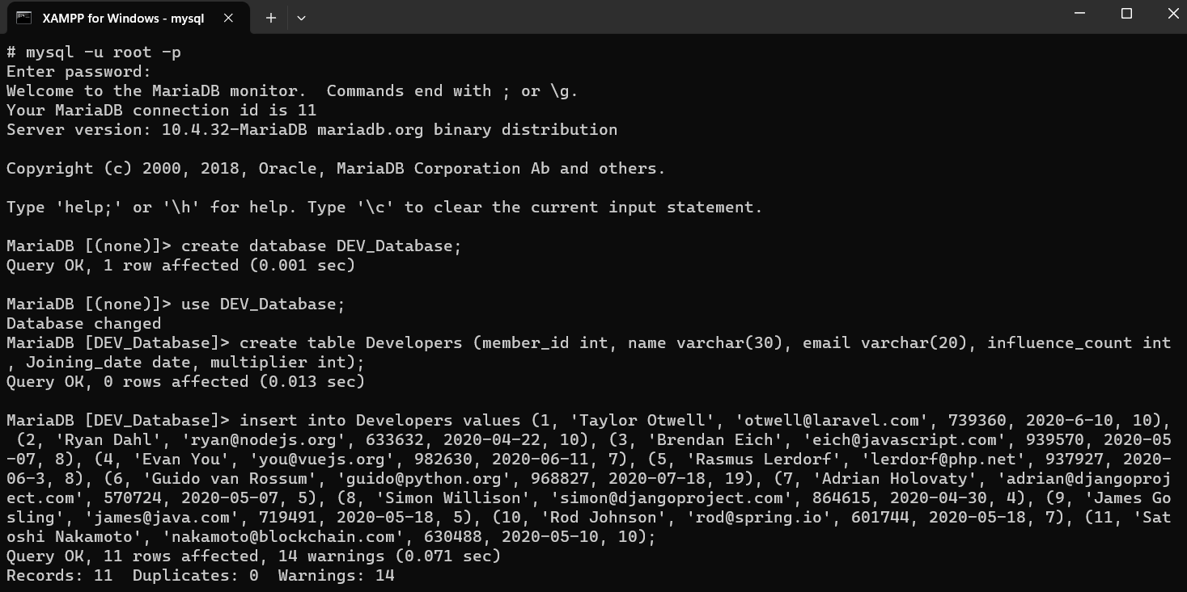

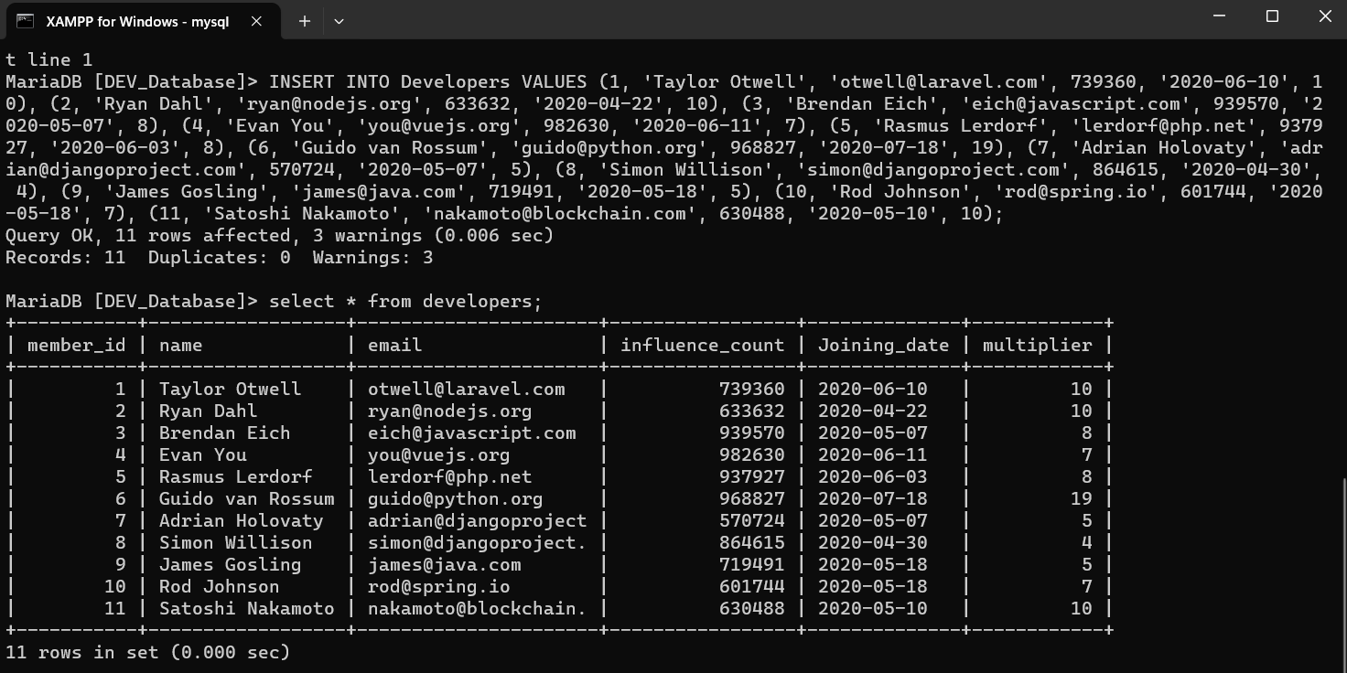

**Task 2:-------**

alter table developers change influence_count followers int;

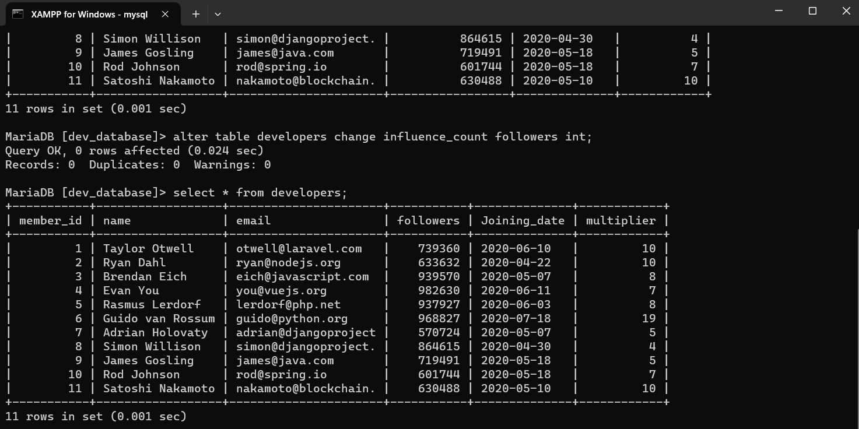

**Task 3:------**

update developers set followers = followers + 10;

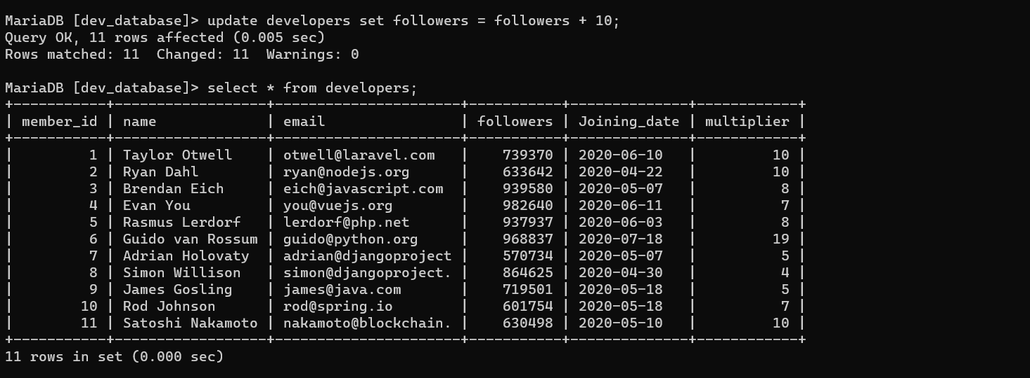

**Task 4:--------**

alter table developers add Efficiency double;

update developers set Efficiency = ((followers*100/1000000) * (multiplier*100/20))/100;

select name, efficiency from developers;

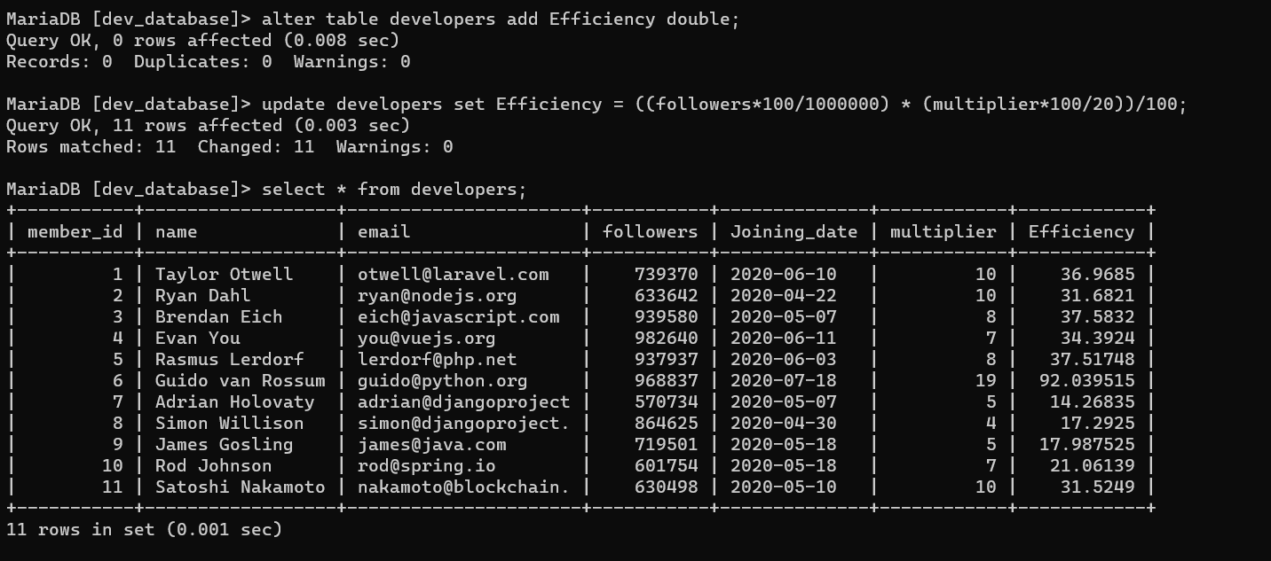

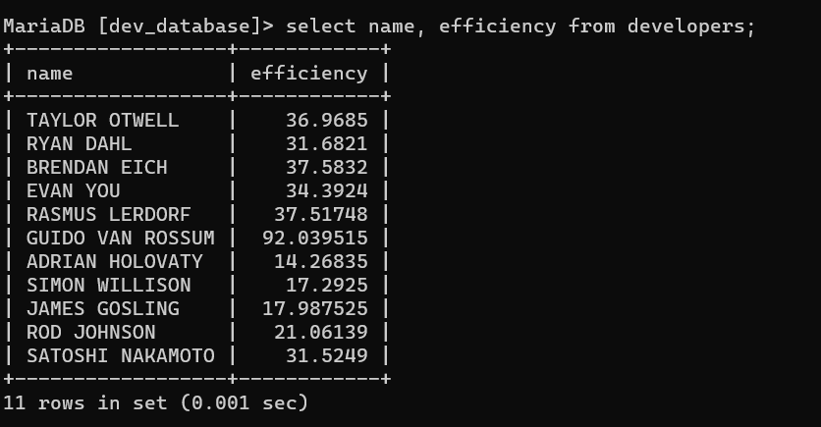

**Task 5:------**

select upper(name), joining_date from developers order by joining_date desc;

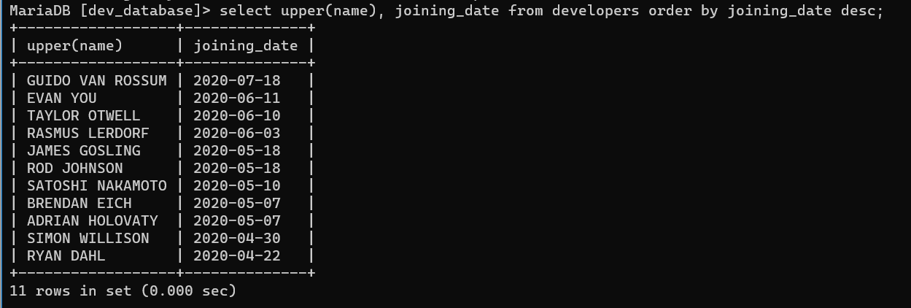

**Task 6:-------**

Select member_id, name, email, followers from developers where email like '%.com' or email like '%.net';

